Remy Lagrois

Stats 1 Section 402

HW6

1. With Bonferoni’s method we adjust alpha from .05 to .01667 and use that to calculate the critical t which comes out to -2.5581 for all (since they all have the same N). The resulting confidence intervals are: -2.36 to -0.639 (amputee – crutches), -1.116 to -0.712 (amputee – wheelchair), and -0.03 to 1.19 (crutches – wheelchair). This shows that while there may be some difference between the two groups it is not practically very significant which agrees with pervious tests done with this data.
2. I used the following proc code to answer this question in SAS:
3. **proc** **glm** data = handi;
4. class Hcap;
5. model score=Hcap;
6. means Hcap / bon LSD DUNNETT Tukey scheffe;
7. **run**;

All of the half widths were very similar to those listed in the book. They all were the same at least to the hundredths place and only differed in the thousandths or lower

3. a) Nearly all of the pairs have a statistically significant difference at alpha = .05. The only pairs that don’t are the <12/12 pair and >16/16 pair. In the table, ‘***’ represents significant differences. 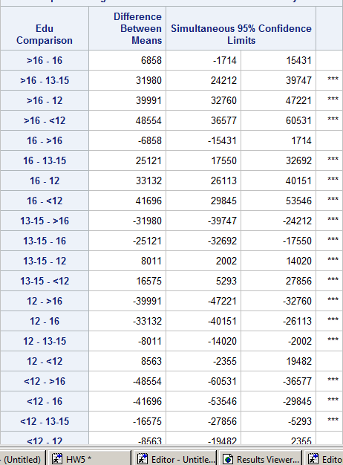

b) The >16, 16, and 13-15 groups all differ from the 12 group in a statistically significant way at alpha = .05. The differences in means are $39,991, $33,132, and $8,011 respectively.